PI Authorization for User access and Billing of core services

This form is for the PI of the User to complete to authorize that the USER has the PI’s permission to utilize the specified flow core services. This form shall be completed at the time the USER requests access to the Flow Core, and before any training is started.
Name of USER: Click or tap here to enter text.
Name of PI: Click or tap here to enter text.
PI Email: Click or tap here to enter text.
PI Phone Number: Click or tap here to enter text.

PI should check off the services USER is allowed to utilize in the NSU Flow Core:
☐ Use of the BD Fortessa X-20
☐ Use of the HTS that can be connected to the Fortessa.
☐ Sorting cells on the BD AriaFusion.
☐ After hours and weekend access to Flow Core (No Sorting).
☐ Using Flow Core personnel in a fee for service fashion.
(We will tell a user if they will incur charges when they request something.)
☐ Use of the Flow Core data analysis stations
☐ Purchasing a copy of FlowJo analysis software license.
☐ Use of NSU Flow Core computer analysis stations
Flow Core Pricing
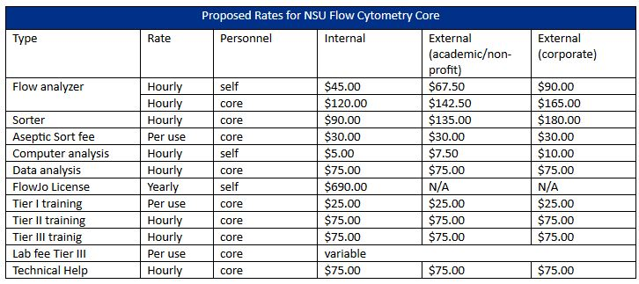

PI acknowledges the following:
☐ Monetary costs associated the Use of the NSU Flow Core.
☐ User has completed all EH&S training as required by NSU.
☐ Completed “Sample Types” form for every sample type USER will use in the core.
☐ User has been trained by the PI in any hazardous material, infectious agents, and genetic modifications
the USER may bring into the Flow Core.
☐ User has been trained by the PI in the proper procedure for inactivating flow cytometry samples by
fixation.
☐ Violation of NSU Flow Core Policies & Procedures
Billing:
Please enter the NSU Account # for USER: Click or tap here to enter text.
PI Electronic Signature: Click or tap here to enter text.
☐ I understand that checking this box constitutes a legal signature confirming that I acknowledge and agree to the above.

